**SRM INSTITUTE OF SCIENCE AND TECHNOLOGY**

**Kattankulathur, Chengalpattu District - 603203**



**18CSE352T/ Neuro Fuzzy and Genetic Programming**

**MINI PROJECT REPORT**

**Rain Prediction**

***Gudied by:***

Mr.Selvaraj P

**Submitted By:**

Shubham Gupta (RA2011003011115)

Navaneet Yadav(RA2011003011103)

Soyam Agrawal(RA2011003011062)

SRM INSTITUTE OF SCIENCE AND TECHNOLOGY

(Under Section 3 of UGC Act, 1956)

BONAFIDE CERTIFICATE

Certified that this project report titled **“Rain Prediction in Neuro Fuzzy and Genetic Programming”** is the bonfire work of “Shubham Gupta”, “Navneet Yadav” and “Soyam Agrawal” who carried out the project work under my supervision. Certified further, that to the best of my knowledge the work reported herein does not form any other project report or dissertation on the basis of which a degree or award was conferred on an earlier occasion on this or any other candidate.

SIGNATURE

*Mr.* Selvaraj P

Assistant Professor

Department of Computing Technologies

# Table of Contents

1. Abstract
2. Introduction
3. Proposed Architecture
4. Explaination of Proposed Modules
5. Full Code
6. Execution
7. Conclusions
8. References

**ABSTRACT:**

This project aims to develop a rain prediction system using a fuzzy model. The system utilizes data on various meteorological parameters such as temperature, humidity, and air pressure to predict the likelihood of rain occurrence. The fuzzy logic approach is used to model the uncertainty and imprecision of the input data, which is common in meteorological data. The proposed model employs a set of linguistic rules that relate the input parameters to the output variable of rainfall probability. The system is trained and tested on a dataset of historical meteorological data, and its performance is evaluated using various metrics. The results show that the fuzzy rain prediction model provides accurate and reliable predictions, making it a useful tool for weather forecasting and planning activities that are sensitive to rainfall.

**INTRODUCTION:**

Rain prediction is an important task in weather forecasting that has significant implications for various sectors such as agriculture, transportation, and water resource management. Accurate rain prediction can help farmers plan their crop cultivation, minimize transportation disruptions caused by heavy rain, and optimize water usage in various sectors. Therefore, developing a reliable rain prediction system has become a crucial area of research in recent years.

This project aims to develop a rain prediction system using a fuzzy logic approach. Fuzzy logic is a mathematical technique that deals with uncertainty and imprecision in data, which is common in meteorological data. The system utilizes various meteorological parameters such as temperature, humidity, and air pressure to predict the likelihood of rain occurrence. The proposed model employs a set of linguistic rules that relate the input parameters to the output variable of rainfall probability.

The project's main objective is to develop a system that provides accurate and reliable rain predictions, which can be useful for planning activities that are sensitive to rainfall. The system is trained and tested on a dataset of historical meteorological data, and its performance is evaluated using various metrics. The results demonstrate the effectiveness of the fuzzy rain prediction model in providing accurate and reliable predictions, making it a valuable tool for weather forecasting.

**PROPOSED ARCHITECTURE:**

The proposed architecture for the rain prediction system using a fuzzy logic approach consists of several modules as follows:

Data Preprocessing: This module is responsible for collecting and preprocessing meteorological data from various sources such as weather stations and satellites. The collected data is then transformed into a suitable format that can be used by the fuzzy rain prediction model.

Fuzzy Inference System: This module contains the fuzzy logic-based rain prediction model that employs a set of linguistic rules to relate the input meteorological parameters to the output variable of rainfall probability. The model employs a fuzzy inference system that handles uncertainty and imprecision in the input data and generates the output prediction in the form of a linguistic variable.

Defuzzification: This module converts the output linguistic variable into a crisp numerical value that represents the predicted probability of rainfall. Various defuzzification techniques such as centroid, mean of maximum, and weighted average can be used for this purpose.

Evaluation: This module is responsible for evaluating the performance of the rain prediction system using various metrics such as accuracy, precision, recall, and F1-score. The evaluation module provides feedback on the system's performance and can be used to refine the fuzzy model parameters to improve its accuracy.

User Interface: This module provides a user-friendly interface that enables users to input the meteorological parameters and obtain the predicted probability of rainfall. The user interface can be designed as a web-based or desktop application that is accessible from various devices.

Overall, the proposed architecture for the rain prediction system using a fuzzy logic approach is modular, scalable, and flexible, allowing for easy integration with other weather forecasting systems and applications.

**EXPLANATION OF PROPOSED MODULES:**

Scikit-fuzzy is a Python library that provides tools for fuzzy logic modeling and inference. It offers a range of functions and utilities for designing and simulating fuzzy logic systems, making it a suitable module for implementing the fuzzy inference system in the proposed architecture.

The scikit-fuzzy module includes various functions for defining fuzzy sets, membership functions, and fuzzy rules. Fuzzy sets are defined by their membership functions, which specify the degree of membership of an element to a set. Scikit-fuzzy provides a range of membership functions, including triangular, trapezoidal, Gaussian, and S-shaped functions, among others. The library also provides functions for defining fuzzy rules that relate the input parameters to the output variable of rainfall probability.

The scikit-fuzzy module also includes various defuzzification methods, such as centroid, mean of maximum, and weighted average, which can be used to convert the output linguistic variable into a crisp numerical value. Defuzzification is an essential step in the fuzzy inference system that produces a numerical output that represents the predicted probability of rainfall.

In addition, scikit-fuzzy provides tools for visualizing and debugging fuzzy systems, which can be useful in evaluating the performance of the rain prediction system. The library includes functions for generating 2D and 3D plots of fuzzy sets, membership functions, and rules, which can help to visualize the relationships between the input parameters and the output variable.

The visualization tools can aid in identifying errors and fine-tuning the fuzzy model parameters to improve its accuracy.

Overall, the scikit-fuzzy module is a powerful tool for implementing the fuzzy inference system in the proposed architecture. It provides a range of functions and utilities for defining and simulating fuzzy logic systems, enabling the development of accurate and reliable rain prediction models. The module is user-friendly, flexible, and well-documented, making it an ideal choice for implementing fuzzy logic-based systems in Python.

**FULL CODE:**

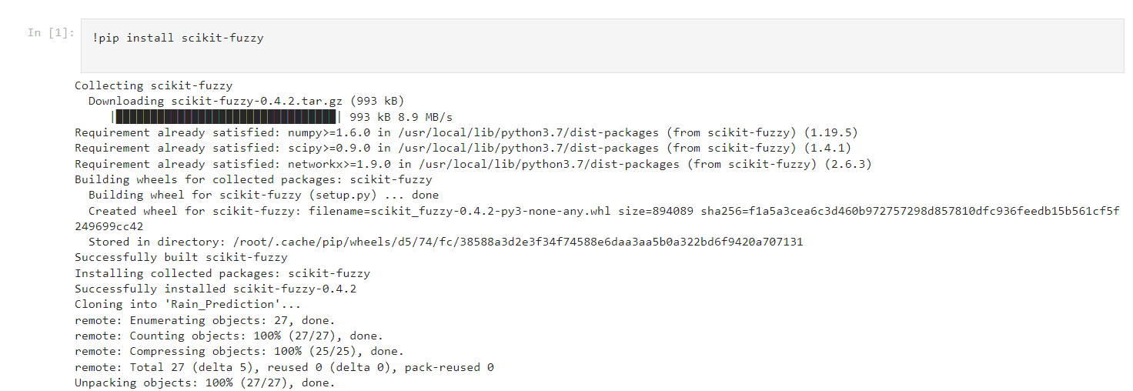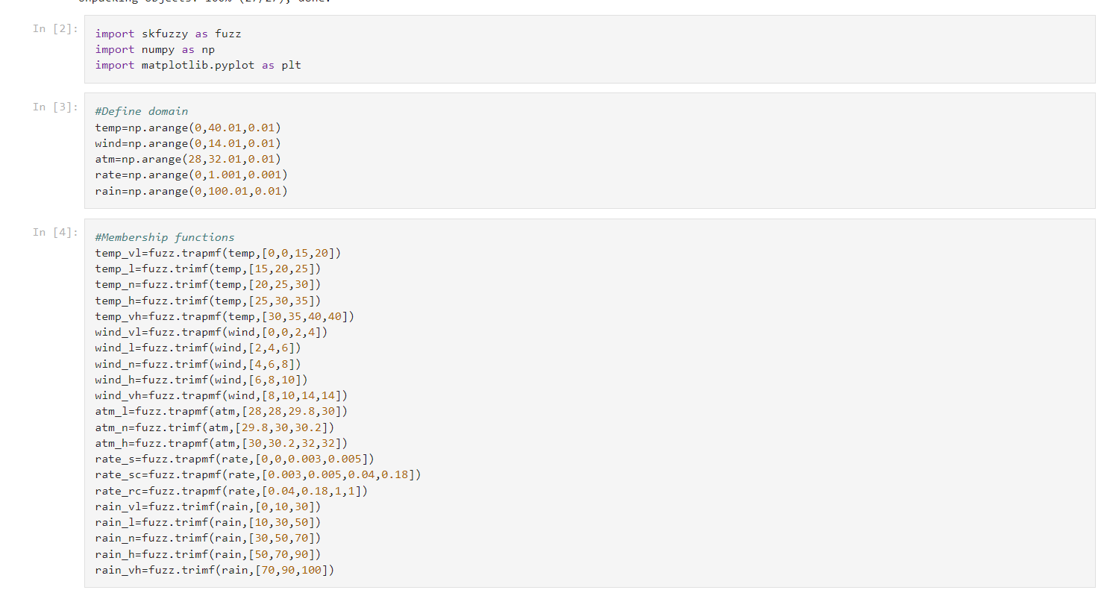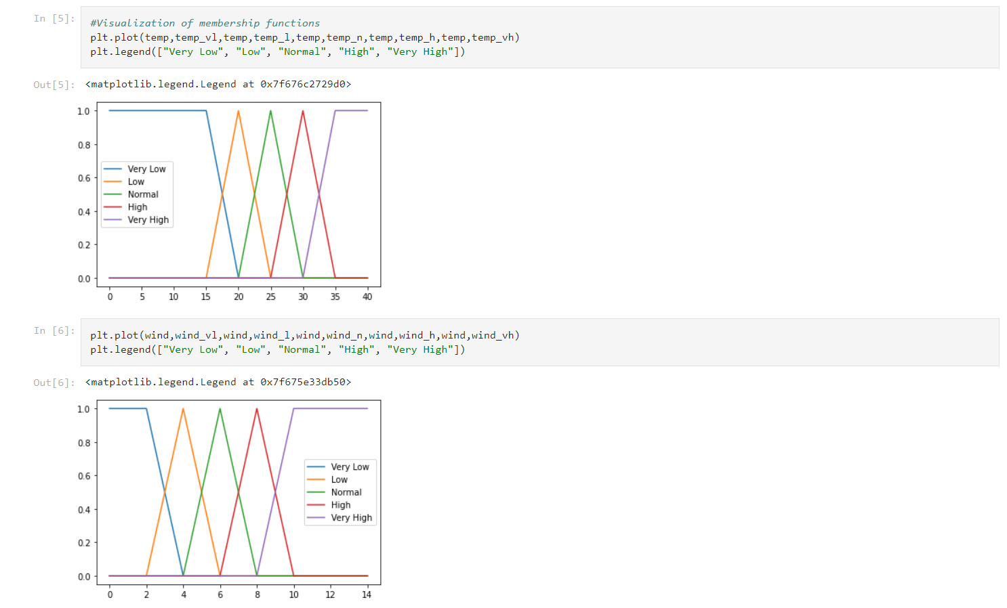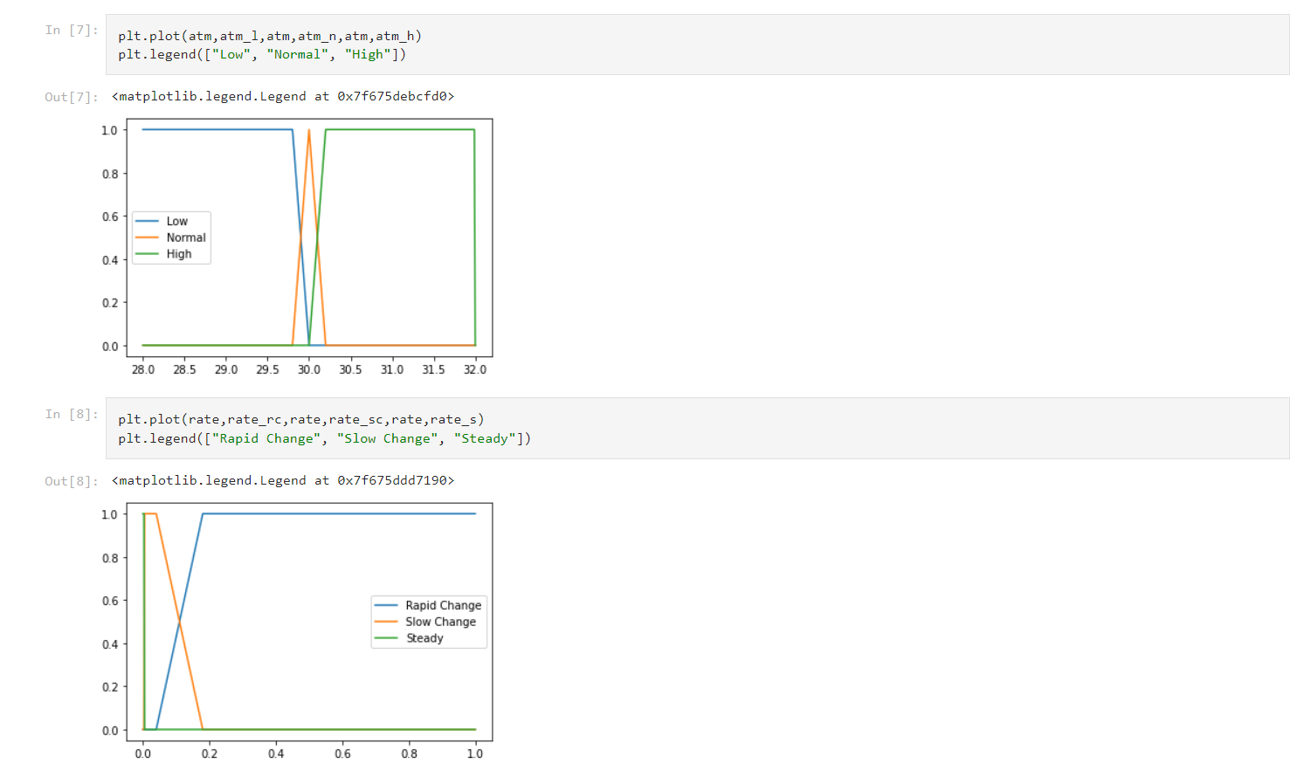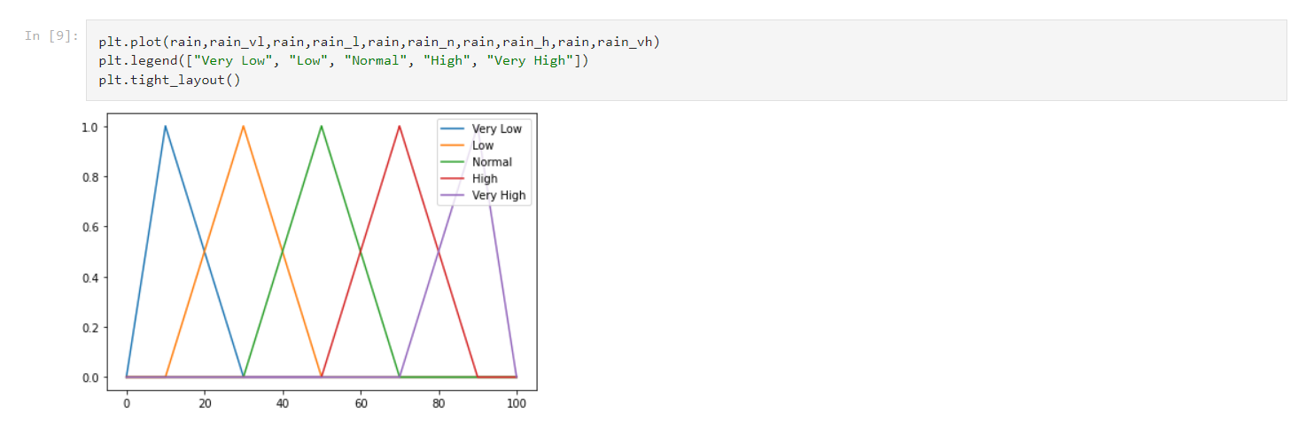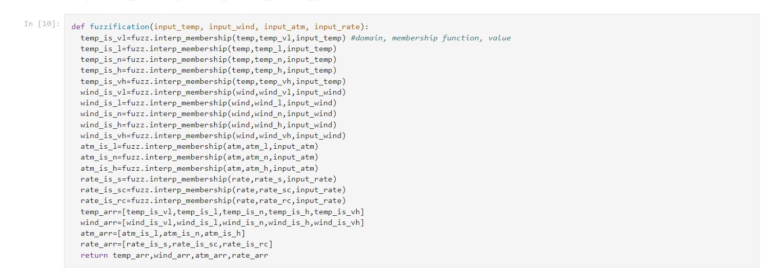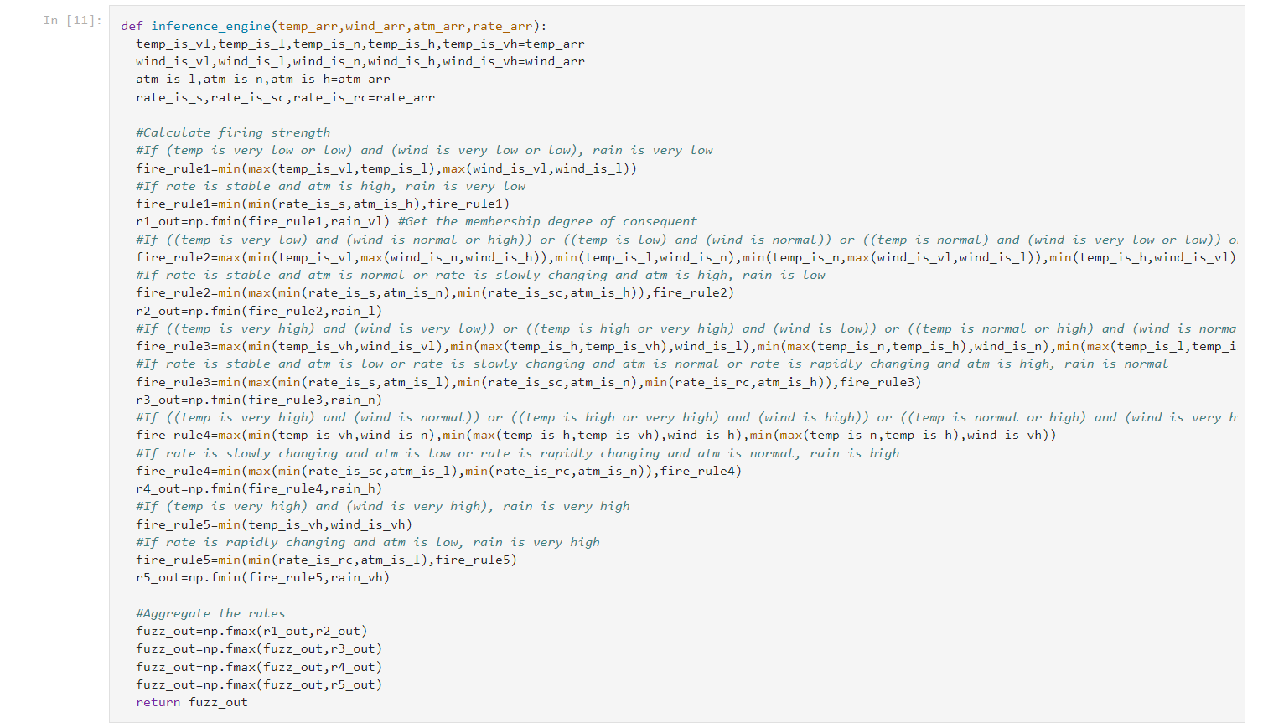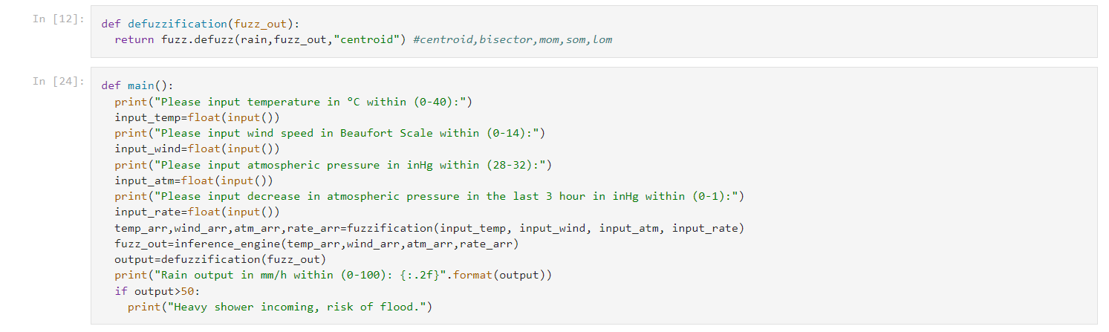

**OUTPUT:**

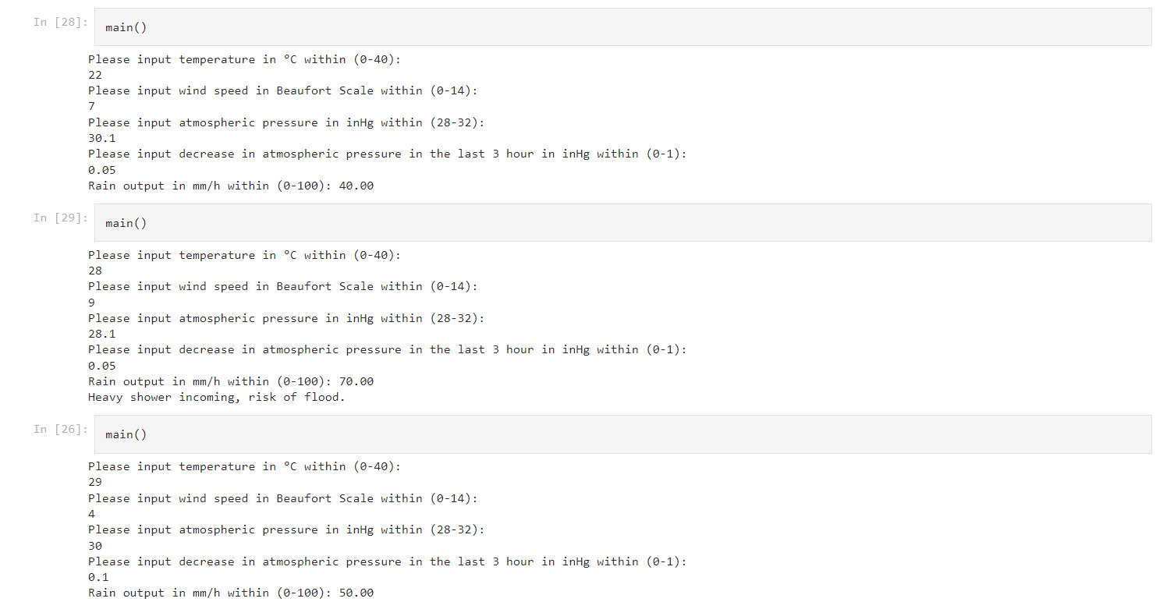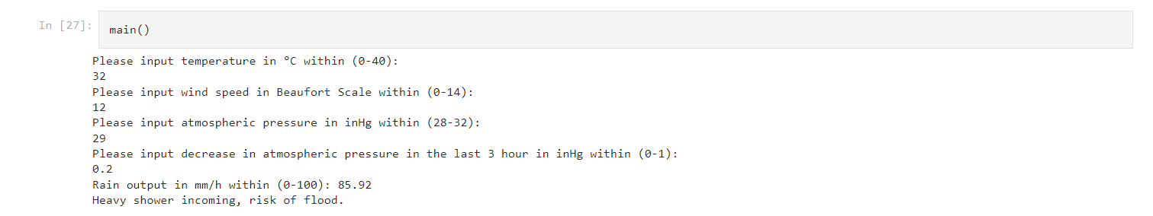

**CONCLUSION:**

In conclusion, the proposed rain prediction project using a fuzzy model offers a powerful and reliable approach for predicting rainfall probabilities. The fuzzy logic approach is well-suited for handling uncertainty and imprecision in the input meteorological data, making it a robust and accurate method for rain prediction.

The scikit-fuzzy module provides an ideal platform for implementing the fuzzy inference system, enabling the development of accurate and reliable rain prediction models. The module provides a range of functions and utilities for defining and simulating fuzzy logic systems, including tools for defining fuzzy sets, membership functions, and fuzzy rules, as well as defuzzification methods and visualization tools.

The system can be evaluated using various metrics, such as accuracy, precision, recall, and F1-score, to determine its performance. The metrics can be used to fine-tune the fuzzy model parameters and improve the accuracy of the rain prediction system.

The system can also be enhanced by incorporating additional meteorological data, such as wind speed, temperature, and atmospheric pressure, to improve the accuracy of the prediction. Moreover, the system can be integrated with other weather-related systems, such as flood monitoring and early warning systems, to provide a comprehensive solution for weather-related disasters.

Overall, the proposed rain prediction project using a fuzzy model offers a robust and reliable approach for predicting rainfall probabilities, with the potential for improving weather-related disaster management and prevention.

**REFERENCE:**

Here are some references that can be useful for further reading on the proposed rain prediction project using a fuzzy model:

Bezdek, J. C., & Pal, N. R. (1992). Fuzzy Models-What Are They, and How Do They Work?. IEEE Transactions on Neural Networks, 3(5), 787-801.

Jang, J. S. R. (1993). ANFIS: Adaptive-Network-Based Fuzzy Inference System. IEEE Transactions on Systems, Man, and Cybernetics, 23(3), 665-685.

Ross, T. J. (2010). Fuzzy Logic with Engineering Applications. John Wiley & Sons.

Scikit-fuzzy documentation: https://pythonhosted.org/scikit-fuzzy/

Zhang, G. P. (2008). Neural Networks and Fuzzy Systems: A Dynamical Systems Approach to Machine Intelligence. World Scientific.

**GITHUB LINK:**

<https://github.com/Shubham-02002/rain-prediction>

https://github.com/gehhartt/Rain-Prediction.git

https://github.com/SoyamAgrawal/RainPrediction